<https://data.unicef.org/resources/unicef-who-world-bank-joint-child-malnutrition-estimates-2023-edition-interactive-dashboard-2/>

<https://data.unicef.org/topic/nutrition/malnutrition/>

# UNICEF-WHO-World Bank: Joint Child Malnutrition Estimates (JME) - 2023 edition interactive dashboard

May 31, 2023

[Interactive data visualizations](https://data.unicef.org/resources/resource-type/interactive-data-visualizations/)[Publications](https://data.unicef.org/resources/resource-type/publications/)

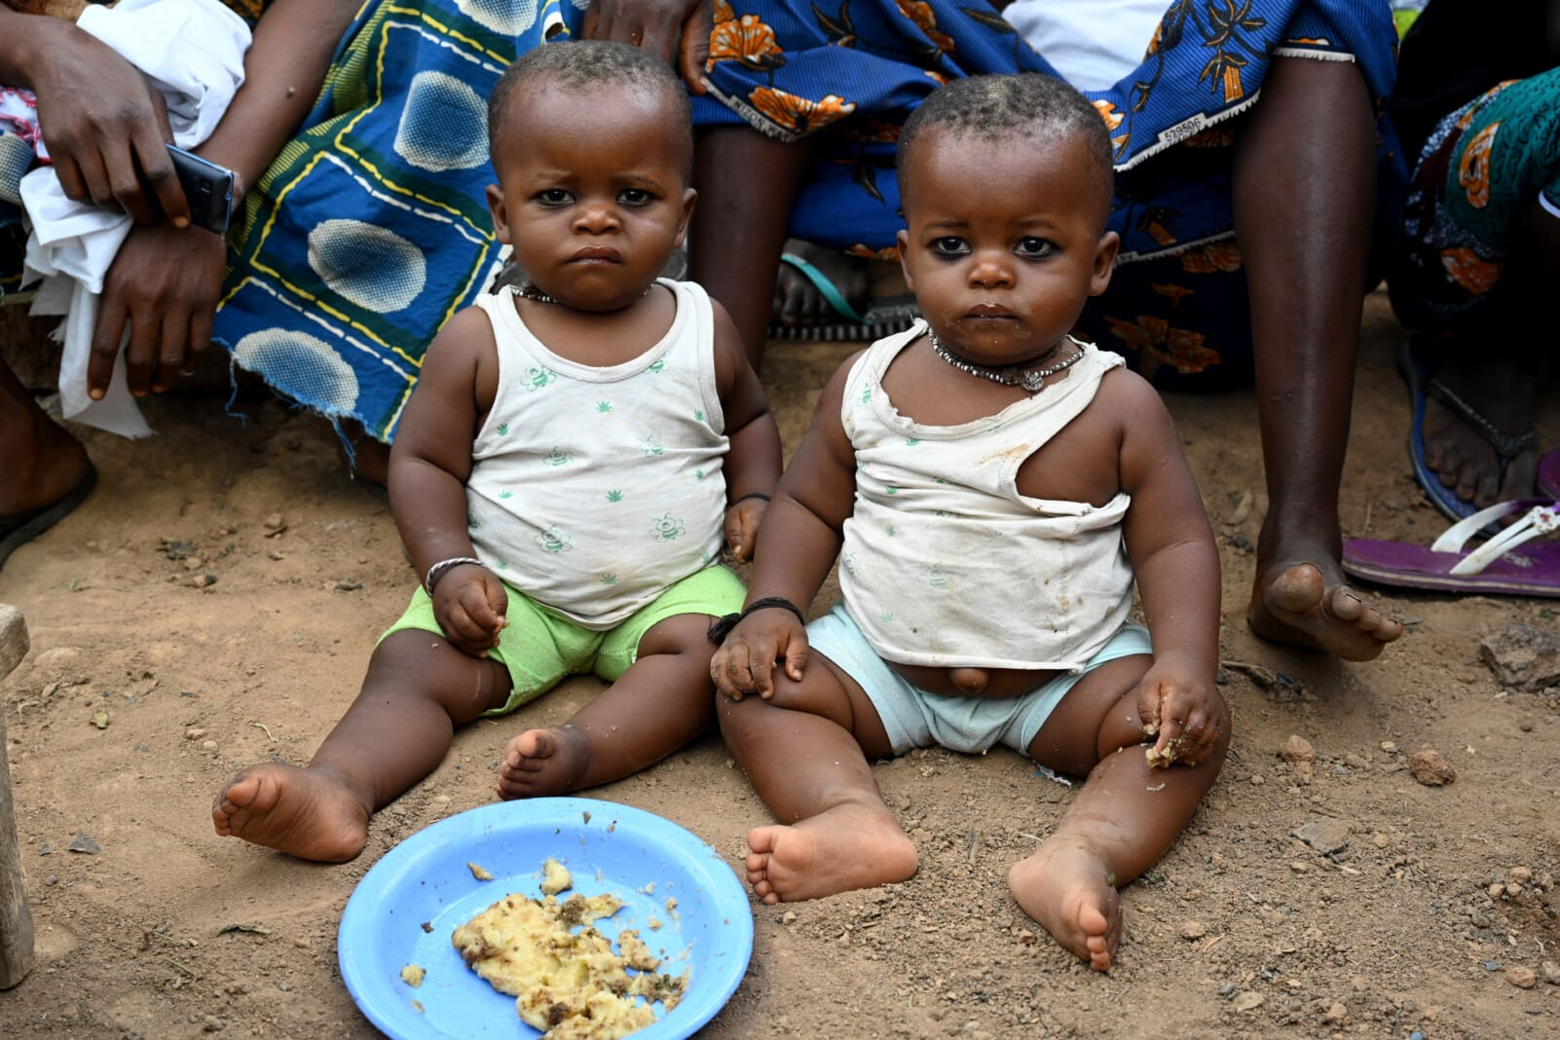

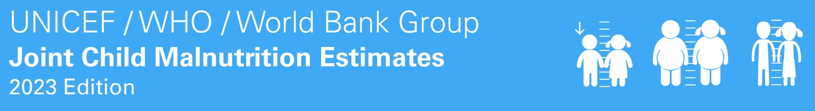

This interactive dashboard visualizes the latest [child malnutrition estimates](https://data.unicef.org/resources/jme-report-2023/) for 2022. These estimates of prevalence and numbers for child stunting, overweight, wasting and severe wasting are derived by United Nations (UN), Sustainable Development Goal (SDG), UNICEF, WHO and World Bank regions, as well as World Bank income group classifications.

## Related Resources